

**CC0006: SUSTAINABILITY, SOCIETY, ECONOMY & ENVIRONMENT**

**T55 Group A1: Measurement for Food Waste in Singapore**

**Group members:**

Lee Bo Hua (U2122595D)

Edwin Chia Yik How (U2140884H)

Hendy (U2122559J)

Choy Jun Hui (U2110966A)

Leow Wei Jie (U2122666J)

Foo Shu Chen (U2130183A)

**Content Page**

|  | **Page No.** |
| --- | --- |
| Abstract | 3 |
| Introduction | 4 |
| Literature Review | 5-6 |
| Result and analysis | 7-8 |
| Discussion, limitations and analysis | 9 |
| Conclusion | 10 |
| References | 11 |
| Appendix | 12 |

# 

# 

# Abstract

Nowadays, food wastage has become a major concern for sustainability, causing environmental and economical impacts on the world. Countries have been stepping up and implementing measures to tackle food waste. Singapore’s National Water Agency (PUB) launched a series of projects to promote food recycling and use on-site systems to treat food waste at food markets while The United Kingdom focuses on food redistribution to reduce wastage. While these measures have their own advantages, they also have limitations which restrict them from being replicated by other countries. This paper analyses the measures Singapore and The UK implemented to tackle food wastage, assesses the effectiveness of each of them, and provides recommendations to further enhance Singapore’s food sustainability measures. Overall we determined that community kitchens are unsuitable for Singapore due to constraints like a more strenuous work life and cheaper food options. However, increasing public awareness and promoting the reduction of food wastage is nevertheless possible through social media like tik tok challenges, to first foster good food sustainability habits among them, before measures requiring their responsibility can be implemented.

# Introduction: background, objective & purpose

Singapore has achieved significant economic progress, transforming from a Third to First World country in a short few decades. As one of the most densely populated countries in the world, and a global financial and trading hub, a new set of challenges presents the island nation – Sustainability. Among many sustainability challenges, food waste is one significant challenge, contributing a whopping 12% of the total waste generated in Singapore (NEA, 2022). Not only does food waste represent financial loss, it also exacerbates the climate change crisis with its significant greenhouse gas footprint (USDA, 2022). The reduction of food waste aligns with the 12th Sustainability Development Goal(SDG12) of sustainable consumption and production patterns. By meeting this goal, other SDGs like SDG1 of No Poverty and SDG2 of Zero Hunger can also be achieved (see Appendix A). This would also support Singapore’s Zero Waste Masterplan to reduce waste sent to the landfill each day by 30% by 2030 (Oh, 2019).

Several measures have already been put in place by the government. However, are the measures effective? How does it compare to other cities? This paper analyses the measures Singapore and The United Kingdom implemented to tackle food wastage, assesses the effectiveness of each of them, and provides recommendations to further enhance Singapore’s food sustainability measures.

# 

# Case Study

**Case study 1: Singapore's food waste measurement in the food industry**

The amount of food waste generated in Singapore has increased by approximately 20% over the past ten years. Singapore generated around 744 million kg of food waste, equivalent to 2 bowls of rice per person per day, or approximately 51,000 double-deckers in 2019. Rice, noodles, and bread are the most commonly wasted food items [1].

Singapore's government introduced Zero waste Nation by 2030 in 2019, which aims to reduce waste and increase recycling rates. The National Environment Agency (NEA) is a statutory board under Singapore's Ministry of Sustainability and the Environment. It has been tasked to ensure a sustainable environment in Singapore by launching a campaign program such as Food Waste Reduction (FWR) outreach program to encourage adopting innovative ways for food purchase, storage, and preparation to help consumers save money while reducing food wastage at the same time. NEA and the National Water Agency (PUB) launched a series of projects to promote food recycling and use on-site systems to treat food waste at food markets. For example, In 2019, the agency released positive findings that co-digesting food waste and used water sludge can triple biogas yield, showing the feasibility of maximising resource recovery from food waste through co-digestion. However, Singapore needs more resources to build infrastructure [3]. While there have been efforts from the government to ensure sustainability, the involvement of citizens in the effort is limited. Singapore has started public consultation to achieve Zero Waste 2030. However, it only educates people on how to recycle right rather than integral to and influential within the policy [3].

**Case study 2: United kingdom's food waste measurement in the food industry**

The United Kingdom supports the shift towards food redistribution and reuses for human consumption. The outreach of food redistribution is cohesive and independent. The food redistributed comes from surplus food from various sources such as farms, manufacturers, supermarkets, local grocery shops, bakeries, and restaurants. The types of surplus food generated may vary significantly, including agricultural crops, perishable fresh or prepared foods, and nonperishable processed foods [4].

The number of surplus food in the UK has been on the rise due to multiple reasons, such as the appearance of the food, minor blemishes, mislabeling, damaged packaging, expiration date, cancelled orders, overproduction of the food, and leftovers from shops such as bakery and sushi shops. The surplus food will be donated to charity organisations in the UK, such as The Food Foundation, FoodCycle, and The Felix Project.  
 The UK has sustainably used surplus food, which is redistributed for human consumption through different channels: through charities and community-led initiatives by the citizens to feed those in need. The UK encourages the development of secondary markets that sell surplus food in farmers' markets or community shops at discounted prices and the establishment of new value chains and businesses by transforming surplus food into new products, such as jams, chutneys, and juices for resale. From Community-led initiatives, There has been a rise in food redistribution initiatives in London. A few organisations, such as North London Waste Authority (NLWA) and FoodCycle have been cooking surplus food they obtained from charity organisations and redistributing it to the public [5]. FoodCycle has organised free three-course community meals made using surplus food (see Appendix B).

Result & Analysis

As we can see, both Singapore and London have implemented their own measures to manage food waste, and with both setting ambitious targets. For instance, Singapore aims to reduce food waste by 30% while London aims to achieve a 50% reduction by 2030. As such, let’s compare the differences between the 2 countries.

Comparing the similarities between the 2 countries, both Singapore and London have actively implemented successful food waste recycling programs throughout the city. Both countries collect their food waste from the various waste streams and recycle it into useful organic products such as fertilisers or biogas. Furthermore, they spread the awareness of such programs through public education and awareness campaigns. In Singapore, multiple advertisements and posters can be seen at food courts, schools and dining places. While for London, monthly or even weekly fairs (see Appendix B) can be seen throughout the city, with some even giving free food to the public. Thus, If London has been so successful in managing their food waste, why has Singapore not adopted some if not all of the measures in place?   
  
 Firstly, this is due to laws and regulations. Singapore has stricter laws which ensure that food waste is managed properly. For example, food waste in Singapore has to be segregated properly and disposed of individually. Furthermore, even though Singaporeans have been educated on how to recycle correctly, they are not encouraged to participate in the Zero waste policy. Whereas for London, food fairs and donation of foods into community kitchens or fridges, rely more on voluntary measures and incentives (free food) to encourage food waste reduction. Moreover, for Londoners they have been actively participating in volunteering events to support events.

Secondly, it would be the difference in infrastructure and technology. In London, most of the food waste measures rely heavily on manpower. Food waste recycling there is limited to how much we as humans can do; recook foods, donations, recycling etc. Whereas in Singapore, multiple treatment plants and advanced technologies are present which convert food waste into organic products such as fertilisers. Hence, the measures used in London may be seen as not making full use of the technology present in Singapore.

Lastly would be the cultural differences. Both have very different food cultures, which may affect the way in which food waste is handled. Londoners tend to cook more at home compared to Singapore, which may explain the use of community kitchens and fridges or apps such as OLIO. Hence, should community fridges and kitchen or apps be present in Singapore, the effectiveness of reducing food waste may not be as powerful as if it was in London.

# 

# Discussion, Limitation and Implication

**(3 main dimensions society, economy, and environment)**

Food waste can impact our environment when they are disposed of in landfills. They decompose and release methane and other greenhouse gases which lead to global warming. Reducing the amount of food wasted can hence reduce the effects of global warming. One tonne of food wastage is equivalent to 4.2 tonnes of carbon dioxide emitted, increasing our carbon footprint [ ]. Furthermore, it can also reduce acidification, land occupation, freshwater and marine eutrophication, human toxicity and, ecotoxicity which are the environmental impacts of food wastage.

Many resources are used for production and distribution of food such as land, water, electricity, and fuel. It is estimated that 25% of our water is used for production [ ]. An estimate of $940 billion in economic loss is estimated annually with 1 in 9 people remaining undernourished [ ]. Reducing food waste can reduce the demand for food therefore reducing the demand for these resources. Resources can then be more efficiently allocated. A fall in food waste also means lesser resources are required for its management such as manpower, transportation, proper handling, and natural gas used in incinerators. This can result in a greater reduction in resources in these sectors.

The United Nations goals for sustainable development 2, 11, and 12 are the targets of the solution. Through reduction of food wastage, the efficient use of resources allows it to be diverted to those who need it more. For instance, in the most recent earthquake in Turkey, many countries across the globe have provided humanitarian aid [ ]. With lesser environmental impacts, people can live in a healthier environment hence a higher standard of living.

**(Application & limitations for SG)**

The introduction of community kitchen and markets into Singapore’s context may generate greater results as compared to the UK. Singapore’s close-knit society allows greater convenience upon implementation. Sharing of food from different cultures and sharing with neighbours can bring about the “Kampung Spirit”, leading to greater racial harmony. However, such measures could be ineffective. Singaporeans have hectic lives. Singapore is ranked the most overworked country in the Asia-Pacific region with an average of 45 hours per week and a measly 7 days of annual leave [ ]. There is a greater convenience to purchase their food outside as fewer people are willing to cook food. Furthermore, one of the reasons why food waste measures are ineffective is due to individual’s preferences. Some may see it as taking another’s leftovers or think that the food in these community kitchens is not as fresh.

# Conclusion & Recommendations

Without a doubt, food wastage is an issue faced on a global scale. The ramifications of ignoring the problem would be disastrous, and it is vital that we realise not just its environmental impact, but also the effects on societal and economic viewpoints. Though Singapore and London have implemented various measures to mitigate the issue, cultural, regulatory, and infrastructural differences would affect the overall effectiveness of these measures.

Thus, adopting a solution should only be approved only after careful consideration of our country's existing culture and regulations. Applying London's approach to Singapore's context might have ostensible benefits, but said effects must consider the inherent problems faced by existing measures. Circumstances of a strenuous work life, coupled with cheaper food options from hawker centres, impairs the benefits our country can reap from introducing community kitchens and markets. Other factors, such as a worrying lack of proper food waste redistribution habits, must also be accounted for before implementing any measures.

The previous perusal of current publicity and awareness campaigns had revealed that many are aware of the problem, but chose to adopt a laissez-faire attitude. Conversely, the onset of social media platforms has witnessed staggering growth of users jumping onto the bandwagon to partake in various trends and challenges. The exceptional interest often stems from their ease of replicability and high levels of engagement. Similarly, the habit of food distribution can be fostered through proper leveraging of these online challenges. Existing publicity campaigns lack the creativity and dynamic components of these eye-catching novelties. Only by equipping a flexible program structure that seeks to constantly engage the audience, would we be able to attract more people to our cause. Such examples, like a TikTok challenge, would serve as ample impetus for the general public. Afterall, habit is only fostered after a certain level of interest is attained.

Moreover, assimilation of a community kitchen or market is hindered by Singaporean's tendency for eating out owing to tight schedules. As such, responsibility for such food wastage must also rest in the hands of restaurant and food store owners.

Consequently, donation should not be limited to home cooked food, but also food remaining from dishes eaten at restaurants and the likes. The expansion of options would increase the success of such operations in the local context.

Solving food wastage is not the sole end goal. Alongside the alleviation of food insecurity, improvement of the well-being of vulnerable groups in Singapore should also be an objective. Complete erasure of the problem may be challenging, but in the long run, such attempts to change the status quo would benefit Singapore and the countries beyond her.

# 

# References

[1] *Food waste* (no date) *Towards Zero Waste Singapore*. Available at: <https://www.towardszerowaste.gov.sg/foodwaste/>

[2] National Environment Agency -. (n.d.). *Food Waste Management Strategies*. National Environment Agency - Food Waste Management Strategies. Retrieved March 5, 2023, from <https://www.nea.gov.sg/our-services/waste-management/3r-programmes-and-resources/food-waste-management/food-waste-management-strategies>

[3] Monika Rut, Anna R. Davies & Huiying Ng (2021) Participating in food waste transitions: exploring surplus food redistribution in Singapore through the ecologies of participation framework, Journal of Environmental Policy & Planning, 23:1, 34-47, DOI: [10.1080/1523908X.2020.1792859](https://doi.org.remotexs.ntu.edu.sg/10.1080/1523908X.2020.1792859)

[4] Elisa Facchini, Eleni Iacovidou, Jan Gronow & Nikolaos Voulvoulis (2018) Food flows in the United Kingdom: The potential of surplus food redistribution to reduce waste, Journal of the Air & Waste Management Association, 68:9, 887-899, DOI: [10.1080/10962247.2017.1405854](https://doi.org.remotexs.ntu.edu.sg/10.1080/10962247.2017.1405854)

[5] Courage, T. (2019). *Living on Food Waste - Day4*. *YouTube*. YouTube. Retrieved March 5, 2023, from <https://www.youtube.com/watch?v=wIpicKtwGTs&list=PLqyoncgsSqj901S4thDB1ALgqI33jh9Vf&index=5&ab_channel=THEHACK.>

[ ] N. (2021, October 27). *Food Waste [Everything You Need To Know in Westminster]*. Commercial Waste. <https://cleanstreets.westminster.gov.uk/food-waste-what-you-need-to-know/>

[ ] Jeswani, H. K., Figueroa-Torres, G., & Azapagic, A. (2021, April). The extent of food waste generation in the UK and its environmental impacts. *Sustainable Production and Consumption*, *26*, 532–547. <https://doi.org/10.1016/j.spc.2020.12.021>

[ ] Chang, E. (2022, December 13). *International Efforts on Wasted Food Recovery*. EPA. <https://www.epa.gov/international-cooperation/international-efforts-wasted-food-recovery>

[ ] Yeo, S. (2023, February 13). *Donate money, clothes, and supplies: Support the Turkey-Syria earthquake relief efforts from Singapore*. Honeycombers Singapore. <https://thehoneycombers.com/singapore/turkey-syria-earthquake-donations-singapore/>

[ ] Yan, W. (2022, October 31). *Nation of unhappy workers: Why S'poreans are more overworked than everyone else in Apac*. Vulcan Post. <https://vulcanpost.com/807585/why-singaporeans-more-overworked-than-everyone-else-in-apac/#:~:text=However%2C%20workers%20everywhere%20continue%20to,seven%20days%20of%20annual%20leave>

# 

# Appendix

Appendix A: United Nations Sustainable Development Goals

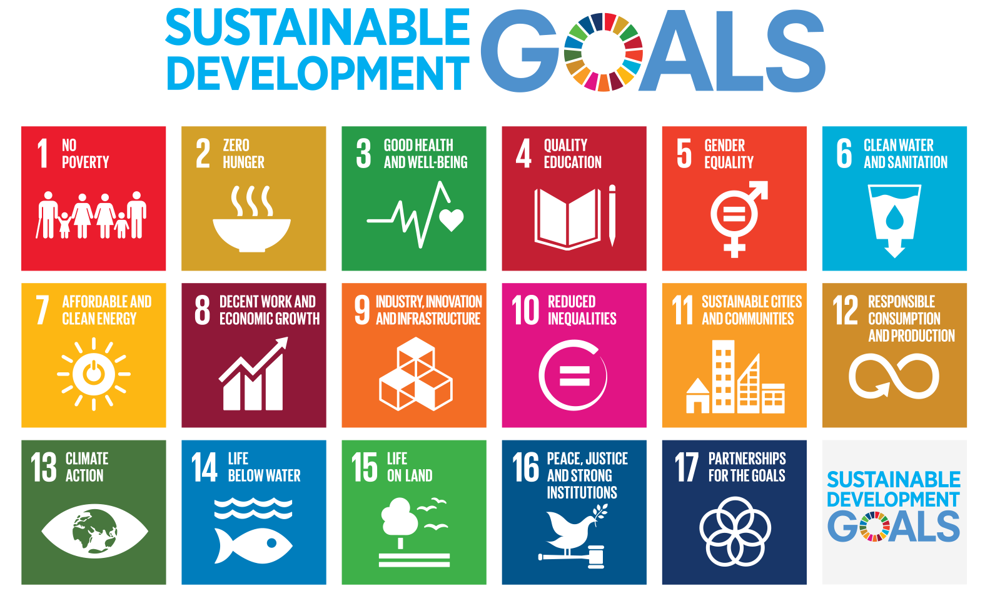

<https://en.wikipedia.org/wiki/Sustainable_Development_Goals#/media/File:Sustainable_Development_Goals.svg>

Appendix B:

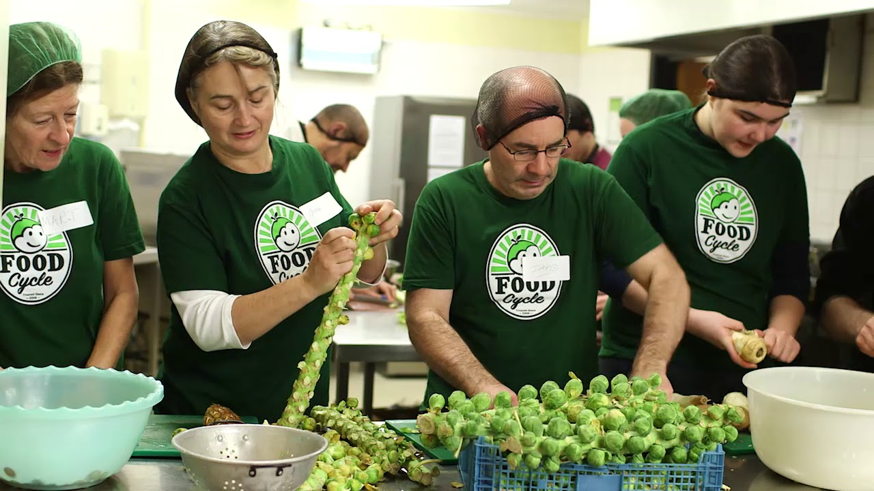

[**https://i.ytimg.com/vi/Vhikt_MzeUU/maxresdefault.jpg**](https://i.ytimg.com/vi/Vhikt_MzeUU/maxresdefault.jpg)

Appendix C:

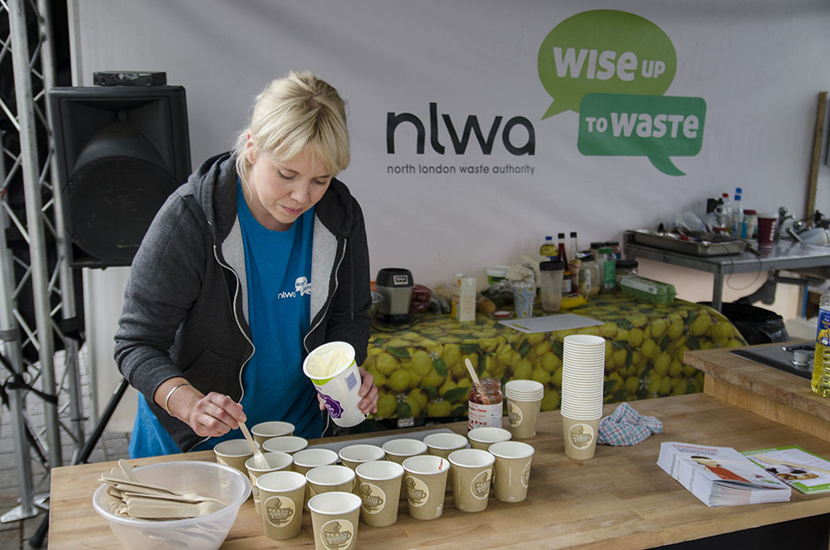

[**https://www.keepbritaintidy.org/news/sometimes-there-such-thing-free-lunch**](https://www.keepbritaintidy.org/news/sometimes-there-such-thing-free-lunch)